

Common European Data Space on Critical Raw Materials for the Green Deal: Recovery Potential from Closed Extractive Coal Waste Facilities
Grant Agreement 101216677

Deliverable X.X

Authors

Author 1, ORGANISATION (Full name, not the Acronym)
Author 2, ORGANISATION (Full name, not the Acronym)
…

Deliverable X.X
Due date of Deliverable | XX.XX.XXXX
Start - End Date of Project | 01.07.2022 – 31.12.2025
Duration | 3.5 years
Deliverable Lead Partner | PARTNER ACRONYM
Dissemination level | Public / Sensitive
Work Package | WP X
Digital File Name | DX.X Title of the Deliverable
Keywords | Keyword 1, keyword 2, keyword 3, keyword 4, keyword 5 (a maximum of 5 keywords)

Disclaimer
The information and photographs in this Deliverable remain the property of the CRMsDataSpace Project or its Partners. You must not distribute, copy or print this information.

Table of contents
Executive Summary 7
1 Introduction 8
2 First level heading 10
2.1 Second level heading 10
2.1.1 Third level heading 10
2.1.1.1 Fourth level heading 10
3 Figures and tables 11
4 Important notice about copyrights and references 13
5 Conclusions & lessons learned 14
6 Glossary 15
7 References 16

List of Figures
Figure 3-1. Graphical abstract of the project 11

List of Tables
Table 3-1. First example of a table 12
Table 3-2. Second example of a table 12

Executive Summary
Here goes the Executive Summary.
It summarises the deliverable so that readers can rapidly become acquainted with all the material without having to read it all.
It usually contains a brief statement of the problem or proposal covered in the deliverable, background information, concise analysis and main conclusions.
No more than one page is desirable.

Introduction
Here goes the introduction.
You can start with the objectives of the specific Work Package, and these objectives can be found in the Technical Annex of the Project. Let us see an example for a Deliverable of Work Package Nº 2:
Work Package Nº2 analyses energy harnessing technologies, strengthening technologies, and green hydrogen deployment. Specific objectives are:
- To select, according to the project’s needs, the most widespread and reliable units on the market for deploying the selected energy harnessing technologies: geothermal, photovoltaic and wind power.
- To select according to the project’s needs the most widespread and reliable units on the market to deploy energy-strengthening technologies: unconventional pumped hydro and batteries.
- According to the project’s needs, select the most widespread and reliable units on the market to deploy green hydrogen.
- To analyse the technical specifications, cost data and operational constraints of the selected alternatives for each renewable energy technology.
- To prepare a detailed assessment of the job creation potential of each alternative per MW installed, per MWh-MW of storage capacity and MW of electrolysers capacity, both for commissioning and operation.
Then, you can follow up with the specific Task. This information can also be found in the Technical Annex. Let us see an example for Task 2.3 corresponding to Deliverable D2.6 Green hydrogen deployment.
Deliverable 2.6 will select the most widespread and reliable units on the market to deploy green hydrogen according to the project’s needs.
The data that will be analysed will address the following aspects:
- Electrolyser capacity (MW).
- The efficiency of electrolyser (MWel/t H2).
- Load hours of electrolysis.
- Hydrogen annual production (tonnes per year).
- The capacity of hydrogen storage in tonnes.
- The yearly production of oxygen (tonnes per year).
- Hydrogen purity.
- Energy consumption.
- Purified water consumption.
- Water purification system and water consumption.
- Investment cost in € per MW of electrolyser.
- Cost of starting up in € per MW of electrolyser.
- The lifetime of units in years.
- Operation and maintenance costs per year in € per MW.
- CO₂ emissions reduction due to the installation of the new facilities in tonnes per year.
FAEN will lead this task with the cooperation of UNIOVI, GIG and DMT-THGA.
Of course, if some mistakes in the descriptions are detected, they must be corrected.

First-level heading
Here starts the first chapter after the introduction.
So that the Table of contents can be automatically updated, you should copy-paste the heading you want to use. To update the Table of contents, go there, click on the right button of the mouse, press “Update field”, and then “Update entire table”.
The same should be done to update the List of Figures and Tables.

Second-level heading
Here follows an example of numbered text with the titles in bold (labels in bold are optional):
- First title: Leveraging the competitive advantages of end-of-life underground coal mines to maximise the creation of green and quality jobs.
- Second title: Leveraging the competitive advantages of end-of-life underground coal mines to maximise the creation of green and quality jobs.
- Third title: Leveraging the competitive advantages of end-of-life underground coal mines to maximise the creation of green and quality jobs.
Here goes an example of a bullet list:
- Leveraging the competitive advantages of end-of-life underground coal mines to maximise the creation of green and quality jobs
- Leveraging the competitive advantages of end-of-life underground coal mines to maximise the creation of green and quality jobs:
  - Bullet list within the main bullet list.
  - Bullet list within the main bullet list.
- Leveraging the competitive advantages of end-of-life underground coal mines to maximise the creation of green and quality jobs.

Third-level heading
Here is an example of a third-level heading.

Fourth level heading
Here is an example of a fourth-level heading. In case more headers are needed, use a numbered/bullet list.

Figures and tables
All figures must be consecutively numbered by using the right button of the mouse, then “Insert caption”, the label “Figure”, position “below selected item”, and numbering “include chapter number”.
Thus, Figure 3-1 presents the result: A caption consisting of the word “Figure,” the figure chapter, a dash, the number within the chapter, and the figure title, in 11-point Calibri (Body), must appear centred below each figure. No blank line separates the figure from its caption.
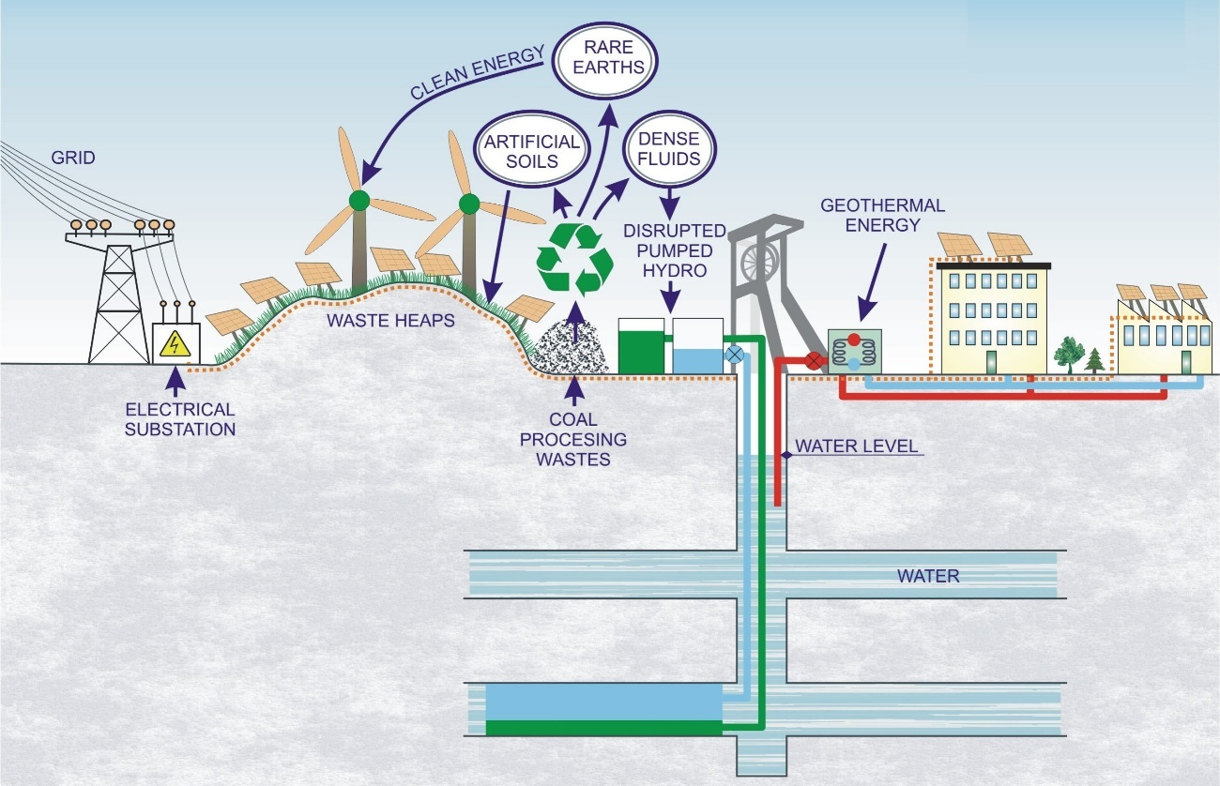
Figure 3-1. Graphical abstract of the project
Figures should be inserted as close as possible to their first citation in the text, as the example given in the previous paragraph: “Figure 3-1”.
To introduce a figure citation in the text, place the cursor where you want to introduce the source, go in the tool menu to “References”, then “Captions”, “Cross-Reference”, Reference type “Figure”, Insert reference to “Only label and number”, select the Figure you want to cite, and press “Insert”.
By doing this, it will be possible to automatically update the numbering in the text in case you introduce a new figure among previous ones.

Regarding tables, the procedure is the same as with figures; the only difference is that captions must appear centred above each figure, as in Table 3-1
Table 3-1. First example of a table
Foreseen projects | Current state or foreseen projects
Scenario I | Scenario I is characterised by a focus on the dominant form of the future…
Scenario II | Scenario II is characterised by maximum …
Scenario III | Scenario III is characterised by…
Here is the format of a paragraph just after a Table.
Following is another table example to select the most appropriate one for your purposes:
Table 3-2 presents another example of a table with more columns.
Table 3-2. Second example of a table
Lad use | CLC 2006 | Scenario I | Scenario II | Scenario III | Procedure and conditions
Case A | 6 | 0 | 0 | 0 | Set to zero in all scenarios.
Case B | 7.2 | 0 | 0 | 0 | Only in Scenario II and in several important affected areas.
Case C | 2.9 | 3.8 | 2.9 | 2.9 | Only in Scenario III and in other areas.

Important notice about copyrights and references
Partners should be aware that all the deliverables but three of the GreenJOBS Project are PUBLIC, so that they will be automatically posted online on the European Commission Project Results Platform and the Project webpage.
Thus, no Figures or Tables can be copied in the text if you are not the authors or have written permission.
Also, any citation made should be adequately referenced according to the following rules:
- One author, after the citation: (Godet, 2000).
- Two authors, after the citation: (Larondelle & Haase, 2012).
- Three or more authors, after the citation: (Altun et al., 2010).
- If the reference is not after the citation: Larondelle & Haase (2012).
- Various citations: (Godet, 2000; Altun et al., 2010; Larondelle & Haase, 2012).
The three SENSITIVE Deliverables, this is, the ones that will not be posted or made available to the public, only to the Project reviewers, are:
- D4.1 A renewable-powered future for the Bobrek-Piekary complex in Poland (GIG), month 24.
- D4.2 A renewable-powered future for the Aller-Barredo-Figaredo complex in Spain (UNIOVI), month 24.
- D4.3 A renewable-powered future for the Velenje mine in Slovenia (GIG), month 24.

Conclusions & lessons learned
This report’s final section presents the main conclusions and lessons learned.
Only one or two pages are desirable.
The lessons learned should appear as a numbered list, as they will be used to feed the Project’s webpage. Here goes an example:
The lessons relevant to the Project from this deliverable can be summarised as follows:
- Multi-criteria decision analysis was developed to determine the best choice based on the scores of different criteria and the relative weights given to those criteria. However, assigning relative weights to criteria that have been evaluated with varying assessment methods is complicated.
- Non-provisioning ecosystem services have to be quantified in the first place using tables of coefficients for each land cover type derived from field experiments. Then, they will be transformed into a standard metric employing local scaling instead of global scales that may cause irrelevance differences between local measures.
- The source of uncertainty in these valuations will be the different values in different climatic environments/conditions and assumptions based on specific areas or circumstances.
- Finally, monetisation of all non-provisioning ecosystem services should be built on the above comparison and the monetary valuation of the attribute with the most direct and market-related valuation possible: carbon sequestration using the EU Emissions Trading System.

Glossary
You can erase the ones not used or add new ones as necessary:
CAPEX – Capital expenditure
COP – Coefficient of performance
DMT-THGA – DMT-Gesellschaft für Lehre und Bildung mbH
FAEN – Fundación Asturiana de la Energía
GIG – Główny Instytut Górnictwa
HUNOSA – Hulleras del Norte, S.A.
ICP-AES – Inductively coupled plasma-atomic emission spectrometry
ICP-OES - Inductively coupled plasma-optical emission spectrometry
IRR – Internal rate of return
M&B – Magellan & Barents
NPV – Net present value
OPEX – Operational expenditure
O&M – Operation & maintenance
PP – Payback period
PV – Premogovnik Velenje d.o.o.
REA – Research Executive Agency
SWOT – Strengths, weaknesses, opportunities, and threats
TRL – Technology readiness level
UNIOVI – Universidad de Oviedo
WEGLO – Węglokoks S.A.
XRF – X-Ray Fluorescence

References
Text in bold to be erased.
Papers in journals:
Larondelle, N. & Haase, D. (2012). Valuing post-mining landscapes using an ecosystem services approach - An example from Germany. Ecological Indicators 18, 567–574. https://doi.org/10.1016/j.ecolind.2012.01.008
Meng, L., Feng, Q. yan, Zhou, L., Lu, P. & Meng, Q. (2009). Environmental cumulative effects of coal underground mining. Procedia Earth and Planetary Science 1(1), 1280–1284. https://doi.org/10.1016/j.proeps.2009.09.198
Reports & Legislation:
EEA (2018). Common International Classification of Ecosystem Services (CICES) V5.1 and Guidance on the Application of the Revised Structure. Copenhagen: European Environment Agency. Available on line:
https://cices.eu/content/uploads/sites/8/2018/01/Guidance-V51-01012018.pdf (accessed 9 Nov. 2021).
European Union (2014). Regulation Nº 377/2014 of the European Parliament and of the Council of 3 April 2014 establishing the Copernicus Programme and repealing Regulation Nº 911/2010. Brussels: European Parliament and the European Council. Available on line: https://eur-lex.europa.eu/legal-content/EN/TXT/PDF/?uri=CELEX:32014R0377&from=EN (accessed 9 Nov. 2021).
IRENA (2018). Power System Flexibility for the Energy Transition. Part 2: IRENA FlexTool methodology. Abu Dhabi: International Renewable Energy Agency. Available on line: https://www.irena.org/-/media/Files/IRENA/Agency/Publication/2018/Nov/IRENA_Power_system_flexibility_2_2018.pdf?la=en&hash=B7028E2E169CF239269EC9695D53276E084A29AE (accessed 9 Nov. 2021).
Books:
Harmsworth, C. & Jacoby, J. (2015). Managing Change Initiatives. Real and Simple. Trafford Publishing: Bloomington, Indiana.
Webpages:
EMBER (2021). Daily EU ETS carbon market price (Euros). URL: https://ember-climate.org/data/carbon-price-viewer (accessed 9 Nov. 2021).

Conferences and congress:
Author 1, A.B., Author 2, C.D. & Author 3, E.F. (2020) Title of Presentation. In Proceedings of the Name of the Conference, Location of Conference, Country, Date of Conference (Day Month Year).

